EPTIFIBATIDE INDUCED SEVERE THROMBOCYTOPENIA IN AN ASYMPTOMATIC PATIENT
¹Dr. M. Adnan Raufi MD FACC FSCAI,²Ayesha S. BaigMDRama Siddiqui,³Nouman Akbar
⁴Shakaib Jaffery

International Journal of Drug Discovery and Development
(IJDDD)

Corresponding Author: ¹Dr. M. Adnan Raufi
²Rama Siddiqui

ABSTRACT

Glycoprotein (GP) IIb/IIIa inhibitors are routinely used in patients with acute coronary syndromes. There have been reported platelet counts of below 20 x 10^9/L within hours of administering the drug. We present a case of a 44 years old man with inferior wall myocardial infarction and third-degree heart block who was transferred to our hospital for cardiac catheterization. The patient successfully underwent percutaneous intervention to right coronary artery and eptifibatide was given per protocol. 6 hours post-eptifibatide initiation, platelets dropped from 288 x 10^9/L to 24 x 10^9/L. Eptifibatide was stopped and a complete blood count (CBC) was repeated after 2 hours. The platelets had further dropped to undetectable levels showing 0 x 10^9/L. The patient remained completely asymptomatic. Pseudo-thrombocytopenia was ruled out on peripheral smear. Platelet transfusion was considered however, platelets started to rise few hours afterstopping of Eptifibatide.Twelve hours later, platelet count reached 4 x 10^9/L. It continued to show a positive trend and reached upto a level of 293 x 10^9/L after 5 days. Patient was discharged in a stable condition. Due to this rare but significant phenomenon, patients on these drugs should have their platelet count closely monitored. It is also very rare not to have any symptoms after such critically low platelet levels.

KEYWORDS:Platelet count, Asymptomatic thrombocytopenia, Eptifibatide

BACKGROUND
Glycoprotein (GP) IIb/IIIa inhibitorsare routinely used in post-PCI (percutaneous intervention) patients with acute coronary syndromes [1]. They prevent aggregation of platelets and thrombus formationby inhibiting glycoprotein IIb/IIIa receptors on the surface of platelets. These drugs have been reported to have a strong association with thrombocytopenia and it is hypothesized that the severe thrombocytopenia may be due to the naturally occurring preformed antibodies against platelets [2]. Unlike heparin-induced thrombocytopenia (HIT), GP IIb/IIIa inhibitors result in a more acute and severe form of thrombocytopenia. There is a significant drop in platelet count compared to HIT, where the drop is more gradual and rarely below 30 x 10^9/L [3]. Literature review of the cases reported in the past 8 years with profound thrombocytopenia was performed. Majority of the cases had platelet counts between 5 x 10^9/L to 20 x 10^9/L[10]. Due to this rare but significant phenomenon, we present a casethat developed profound thrombocytopenia post-PCI administration of Eptifibatide.
CASE PRESENTATION
A 44 years oldmalewith inferior wall myocardial infarction complicated with third-degree heart block was transferred to our hospital for cardiac catheterization. The heart block resolved spontaneously. His medical history was significant for diabetes mellitus and ischemic heart disease. He was an active cigarette smoker but denied history of alcohol or drug use. He had no family history of bleeding diathesis, autoimmuneand other clotting disorders. His physical exam revealed a temperature of 36 degrees, respiratory rate of 14 breaths/min, blood pressure of 104/67 mmHg , heart rate of 70 beats/minute and his oxygen saturation was 100%. The patient was alert and oriented to time, place and person. Physical Examination was within normal limits.
The patient's EKG revealed an inferior wall myocardial infarction. Initial laboratory work up showedtroponin-T=0.321ug/L(high), Na(sodium)=132mmol/L(low),K(potassium)=4.4mmol/L,Cl(chloride)=98.6mmol/L,creatinine=87umol/L, glucose=19.2mmol/L (high),WBC(white blood cells)=19.06x10^9/L(neutrophils88.3%), Platelets=357x10^9, Hb(hemoglobin)=129g/L(low), Hct(Hematocrit)=0.388L/L (low). Coronary angiography results showed normal Left Main, 30% stenosis in mid Left Anterior Descendingartery, 80% stenosis in the proximal/mid Left Circumflex artery, while the Right coronary artery revealed a 100% stenosis in the mid segment with large thrombus. The ejection fraction was 50%.
The patient successfully underwent PCI to proximal and mid right coronary artery using a 3.0 x 15 mm DES and 3.0 x 23 mm DES respectively. In the distal segment, a 2.5 x 23 mm DES was deployed. The proximal and mid stents were post dilated using 3.0 x 15 mm non-compliant balloon with no residual stenosis. TIMI 3 flow was restored. Patient tolerated the procedure well with no complications. The patient was continued on aspirin, clopidogrel, atorvastatin, insulin (aspart/glargine).
Due to large thrombus load and the fact that clopidogrel was initiated late, the patient was given eptifibatide (bolus) twice and was put on continuous infusion for the next 18 hours. After 6 hours post-eptifibatide initiation, the platelets dropped from 288 x 10^9/L to approximately 24 x 10^9/L. Peripheral blood smear showed critical thrombocytopenia, no platelet clumping (ruling out pseudo-thrombocytopenia), mild leukocytosis and neutrophilia.Further results showed Hb=111g/L, Hct=0.339L/L, WBC=16.02x10^9(neutrophils 71%). Eptifibatide was immediately stopped and CBC was repeated after a few hours. The platelets had further dropped to undetectable levels showing 0 x 10^9/L. Rest of the CBC includedHb=104g/L, Hct=0.319L/L. Importantly, the patient remained completely asymptomatic with no sign of any bleed or bruiseHe remained under close monitoring. Repeated CBC was performed. The platelet count started to rise after few hours of stoppingeptifibatide and 12 hours later, the platelet count was recorded to be 4 x 10^9/L. The platelet count continued to show a positive trend and reached the level of 128 x10^9/L after 5 days. The patient was discharged on the 8th day of admission. Upon discharge, the platelet count was 293 x10^9/L.

He was advised to keep a good dietary glycemic control. Patient was counseled to quit smoking and was discharged on aspirin, metformin, glyburide, atorvastatin, and clopidogrel.

Severe Thrombocytopenia (undetectable levels)
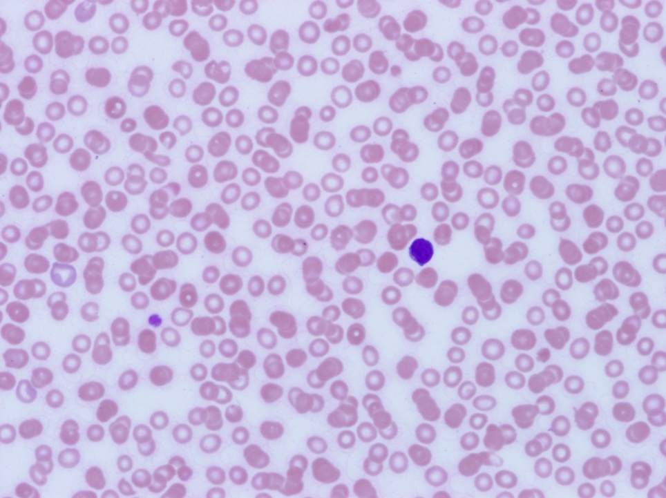

DISCUSSION:
Antiplatelet agents are indicated for the management of vascular diseases. Their role in preventing the formation of arterial thrombi is vital in patients with thrombotic conditions such as atherosclerosis or ischemia. Platelet is activated by the binding of a ligand to its specific receptor. They are integrin receptors containing α2- and β3-subunit. GP IIb/IIIa receptors are found to be the most specific target in inhibiting the aggregation of platelets. These receptors are specific for the binding fibrinogen, which has an important role in the final common pathway of platelet aggregation [5]. The glycoprotein (GP) IIb/IIIa inhibitors approved by the FDA include Abciximab, Eptifibatide and Tirofiban. These drugs are administered via the intravenous route and inhibit the GP IIb/IIIa receptors; however, their binding site and mechanism of actiondiffer. Abciximab was approved by FDA in 1994. It is a monoclonal antibody, which has an inhibitory effect on the GP IIb/IIIa receptors found on the surface of the platelets. Due to its high affinity for receptors, these drugs have a long half-life of dissociation. Therefore, abciximab is associated with an increased risk of thrombocytopenia. Eptifibatide was approved in 1998. It is a heptapeptide against the aforementioned platelet receptors. It has a low affinity for the receptors, which facilitates faster dissociation from the receptor. Tirofiban was also approved in 1998. It is a non-peptide with low affinity to GP IIb/IIIa receptors. Therefore, both eptifibatide and tirofiban possess a reversible effect on these receptors. GPIIb/IIIa inhibitors are used not infrequently during PCI and in the treatment of acute coronary syndromes. Platelets are believed to cause the abrupt closure of the coronary vessel during or after the PCI. Inhibition ofplatelets by the GP IIb/IIIa Inhibitors in PCI is associated with long-term clinical benefits in terms of acute ischemic complications [8]. The effectiveness of the GP IIB/IIIA inhibitor therapy during PCI and patients with UA/NSTEMI especially those with high-risk factors like elevated troponins, diabetesand those that are undergoing revascularization has been well established. However, it has been found that the use of eptifibatide before angiography increase the risk of bleeding without any clear cut benefits[9].It is recommended that GP IIB/IIIA inhibitors should not be used in patients where the risks are more than the benefits such as those patients with normal baseline troponin, non-diabetics and those with age greater than or equal to 75 years. [7]. It has been hypothesized that the strong association of these drugs with severe thrombocytopenia may be due to the naturally occurring preformed antibodies against platelets. The platelet structure is altered by GP IIb/IIIa molecules leading to a platelet/antibody reaction causing acute thrombocytopenia [2]. GP IIb/IIIa inhibitors result in a more acute and severe form of thrombocytopenia with platelet counts of below 15-20 x 10^9/L have been reported within hours of administering the drug[10].This is a significant drop in platelets compared to HIT, where the drop is more gradual and rarely below 30 x 10^9/L [3]. A platelet count should be obtained prior to the administration of the anti-platelet therapy and routine monitoring should be done throughout the course of therapy till discharge. A peripheral smear is important to rule out pseudo-thrombocytopenia, which may be an artifact due to EDTA platelet clumping. GP IIb/IIIa inhibitors should be discontinued immediately once pseudo-thrombocytopenia has been ruled out [4].
CONCLUSION:
Eptifibatide may be associated with acute and severe asymptomatic thrombocytopenia. It is recommended that the patients who are prescribed Eptifibatide may be closely monitored with CBC, Peripheral Smear and periodic physical exams.
REFERENCES:
- Drug-induced thrombocytopenia: Database from Single Case Reports at: http://www.ouhsc.edu/platelets/ditp.html accessed on January 7, 2012.
- Burgess J.K et al. Quinine-dependent antibodies bind a restricted set of epitopes on the glycoprotein Ib-IX complex: characterization of the epitopes. Blood 1998; 92:2366.
- Warkentin TE. Think of HIT. Hematology Am SocHematolEduc Program 2006:408.
- Llevadot J, Coulter SA, Giugliano RP. A practical approach to the diagnosis and management of thrombocytopenia associated with glycoprotein IIb/IIIa receptor inhibitors. J Thromb Thrombolysis 2000; 9:175.
- Hashemzadeh M et al. Chemical structures and mode of action of intravenous glycoprotein IIb/IIIa receptor blockers: A review.ExpClinCardiol 2008;13(4):192-197.
- Amsterdam EA et al. 2014 AHA/ACC guideline for the management of patients with non-ST-elevation acute coronary syndromes: a report of the American College of Cardiology/American Heart Association Task Force on Practice Guidelines.Circulation. 2014 Dec 23;130(25):2354-94
- The EPIC investigators. Use of a monoclonal antibody directed against the platelet glycoprotein IIb/IIIa receptor in high-risk coronary angioplasty. The EPIC Investigation.N Engl J Med. 1994 Apr 7;330(14):956-61.
- Glugliano RP et al. Early versus delayed, provisional eptifibatide in acute coronary syndromes.
N Engl J Med. 2009 May 21;360(21):2176-90. doi: 10.1056/NEJMoa0901316. Epub 2009 Mar 30.
- Raymond Ho, Steven R.Kayser. Thrombocytopenia Associated With Antithrombotic Therapy in Acute Coronary Syndrome. ProgCardiovascNurs. 2003;18(4)
- Nagge J, Jackevicius C, Dzavik V, Ross JR, Sedelin P.
Acute profound thrombocytopenia associated with eptifibatide therapy.
Pharmacotherapy 2003;23:374-9.

